**Mini Project Report**

**On**

**“Doctor’s Appointment Booking”**

**Submitted By:**

**Mr. Atharv P. Ganer**

*submitted to Department of Electronics & Telecommunication Engineering as a part of “Practice School-II: Training on C++ Programming” for the Session 2022-23.*

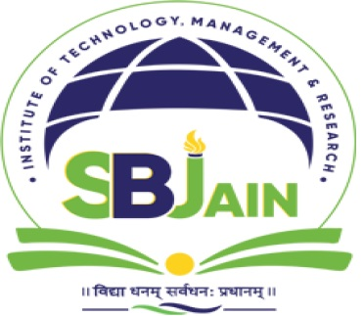

**DEPARTMENT OF ELCTRONICS & TELECOMMUNICATION ENGINEERING**

**S.B. JAIN INSTITUTE OF TECHNOLOGY, MANAGEMENT & RESEARCH, NAGPUR**

**(An Autonomous Institute Affiliated to R.T.M. Nagpur University)**

**(NAAC Accredited with ‘A’ Grade)**